

**Cégep de la Gaspésie et des Îles**

***Continuing Education Service***

**Mobile Application Development**

**LEA.C8**

**End of Program Project**

**420-ENV-MT**

|  |
| --- |
| **Team Members**  **UmaRani Chityala -1793891**  **Sharonjeet Kaur-1798005**  **LoveleenKaur Gill-1794001**  **Srinivas Vuyyuru -1793336** |

|  |
| --- |
| **PROFESSORS**  **Zied Zaier, PhD**  **Lucas Bran**  **Poshtareh Pargol**  **Richard GrandMaison**  **Sakkaravarthi Ramanathan** |

**TABLE OF CONTENTS**

**1**. **Introduction**..................................................................................................................................3

**1.1 Problem Definition** ................................................................................................................3

**1.2 Purpose**....................................................................................................................................4

**1.3 Scope**........................................................................................................................................5

**2. Functional and Non Functional Requirements**....................................................6

**3. Analysis Model**............................................................................................................................6

**3.1. Use Case diagrams**.................................................................................................................7

**3.2. Class diagrams**........................................................................................................................8

**3.3. Prototype- screens**...............................................................................................................10

**3.4. Database-Schema**.................................................................................................................11

**Work Contribution**

|  |  |
| --- | --- |
| ***Name of the Student*** | ***Deliverables*** |
| **UmaRani Chityala**  **1793891** | **Use case diagram, Flow of screens, Documentation, front end and back end connections, web service calls, Mobile coding** |
| **Sharonjeet Kaur**  **1798005** | **Screen Design, Front end and back end connections, web service calls, Mobile coding** |
| **LoveleenKaur Gill**  **1794001** | **Database schema, Screen design, Web service calls, front end and back end connections** |
| **Srinivas Vuyyuru**  **1793336** | **Use case diagram, database schema, Web service calls, front end and back end connections, Mobile coding** |

**1. Introduction**

This software Requirement Specification provides a complete description of best deals of travel, shopping, restaurants and so on. This document will refer to functionality, that is what the resulting application is supposed to do, external interfaces which interacts the users, performance, attributes, that is if the application is portable, or maintainable, and design constraints imposed on the implementation such as implementation language, input specifications and output expectations.

**1.1 Problem Definition**

In order to define the problem, one should imagine a scenario in which a standard customer enters to a Retailer store to know about the best deals. When a customer enters to a store, he finds himself in a huge crowded environment that was difficult to know about the offers and discounts. For a customer to achieve his purpose he should make a lot of effort to find the best offer, what he is searching for. If we want know any best offers which is going on any store, he needs to walk around to know.

Our team intends to solve this problem which is making easier for an ordinary customer by improving the interaction between the customers and their environment. In other words, the real world problem which this project aims to handle is to collect information from the surrounding area without any effort by a standard user, namely customer in a store. The desired information to be collected is expected to consist of finding the locations for the best offers and deals.

**1.2 Purpose**

This application is design to allow a user to find the best deals at nearby stores and also they can share the deals among the users. It helps the user to get the offers for activities, travels, goods and services. This application is more convenient and flexible for the users who are planning to buy something, who are willing to travel, Just a click he come to know the best deals and offers nearby him.

**1.3 Scope**

This mobile application will act not only as a deals searching platform but also as a deals sharing tool between users.

This application is planned to be used by any person who is willing to know about the best daily deals. It is designed to run on a hand-held mobile device.

Following are the features of an application:

* This application has three actors: Guest, user and Admin respectively.
* All the users who are willing to know about the offers need to sign up by giving the basic information.
* This application allows the user to update and delete his profile at any time.
* This mobile application provides access to offers of activities, travel, goods and services.
* The Administrator has privileged to add restaurants, travels and shopping offers and deals and at the same time he can update or delete the existing offers.
* User can share the best deals to his friends.

**Functional Requirements**

**Functional requirements** are the product features or its functions that must be designed directly for the users and their convenience. They define the functionality of the software, which the software engineers have to develop so that the users could easily perform their tasks up to the business requirements.

|  |  |
| --- | --- |
| **Ref.no** | **Description of Functional Requirement** |
| FR-1 | Customer wants to know about the offers, he must create an account. |
| FR-2 | User has already an account; he must login with his valid credentials, then it will be redirected to main page of an application. If the user enters invalid credentials, system will show an error message saying “enter correct username or password”. |
| FR-3 | User who forgot the password of his account, he can click on “Forgot password” button, the password will be reset. |
| FR-4 | User can able to view his profile at any point of time |
| FR-5 | User can search for offers with keyword or with name. |
| FR-6 | User can share the best offers or deals among the users. |
| FR-7 | User can able to change or update his profile. |
| FR-8 | User can delete his account any point of time. |
| FR-9 | User can come out from an application. |
| FR-10 | Admin can add, update and delete the nearby restaurants. |
| FR-11 | Admin can add the best offers and deals according to the occasion. |
| FR-12 | Admin can delete the existing offers. |

**Non- Functional Requirements**

Non-functional requirements describe how a system must behave and establish constraints of its functionality. They specify criteria that judge the operation of a system, rather than specific behaviours such as Performance, capacity, security and maintainability etc..

|  |  |
| --- | --- |
| **Ref.No** | **Description** |
| NFR-1 | This application can be functional in either Android or IOS. |
| NFR-2 | This mobile application is user friendly. User must be able to know about the offers within 8<tab> clicks (Approximately). |
| NFR-3 | In our application performance is a quality attribute. For example: The front-page load time must be no more than 2 seconds for users |
| NFR-4 | This application attendancy limit must be scalable enough to support 600-700 users at a time. |
| NFR-5 | Access permissions for the particular system information only changed by the system’s data administrator. So that software is protected from unauthorized access to the system and its stored data. |
| NFR-6 | System screen must be refreshed within two second. |
| NFR-7 | Application must have consistent updates to keep up with requests and current technologies. |
| NFR-8 | Availability of an application must be online. |
| NFR-9 | App should support WIFI, LTE network protocols. |
| NFR-10 | App should properly display the information in different sizes of IOS and android devices. |

**Use Case Diagram**

A Use case diagram is the primary form of system/software requirements and it specify the expected behaviour (what), and not the exact method of making it happens (how).

The below use case summarizes the relationships between actors, use cases and systems. User and admins are actors who have their own functions to do.

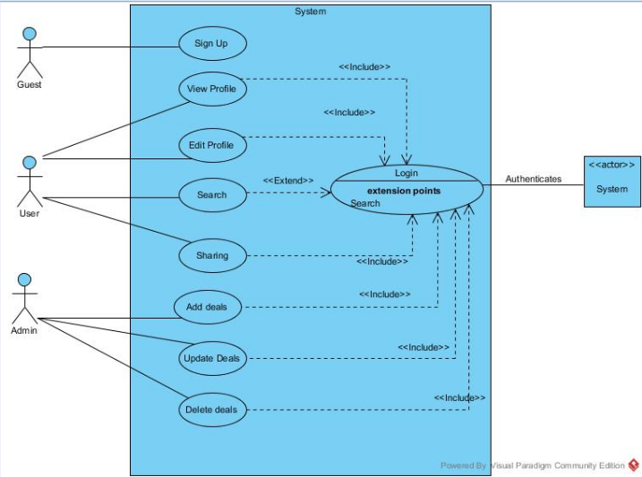

**Figure 1.2 Use case Diagram**

**Class Diagram**

A Class diagram in the Unified Modeling Language is a structure diagram that describes the structure of a system by showing the system's classes, their attributes, operations (or methods), and the relationships among objects.

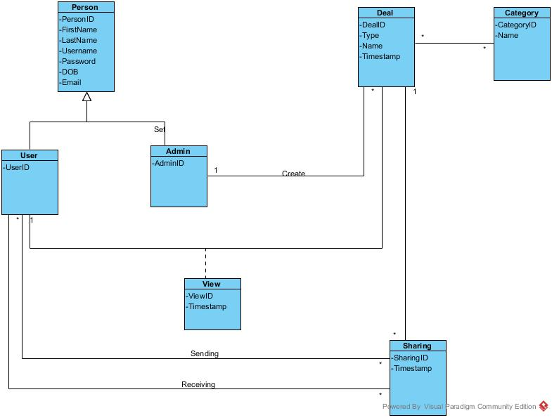

**Figure 1.2 Class Diagram**

**Screen flows diagram**

This flow of screens will give us the better understanding of navigation of an application to the user.

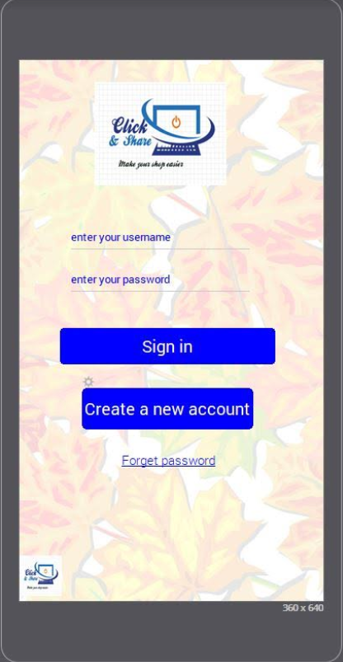

**Welcome page Login page**

Once the User Registered, again login to an app

If the user is login first time

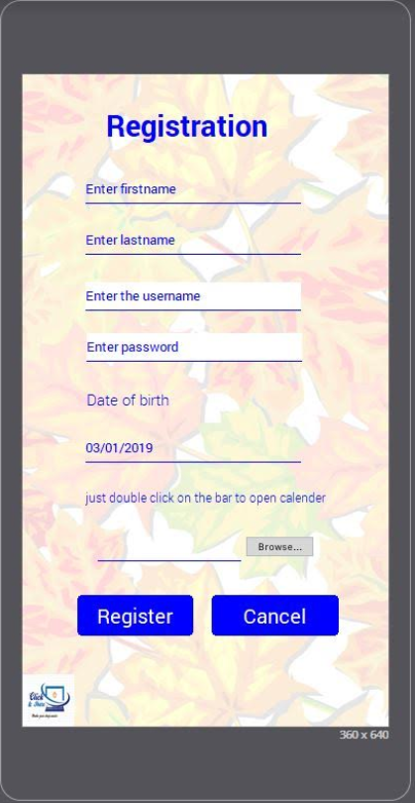

**Registration Screen**

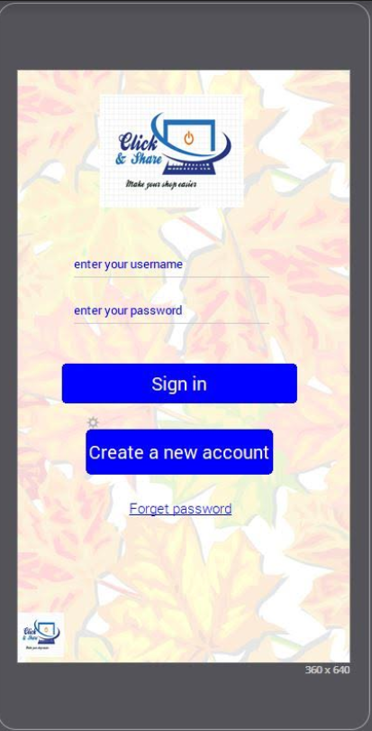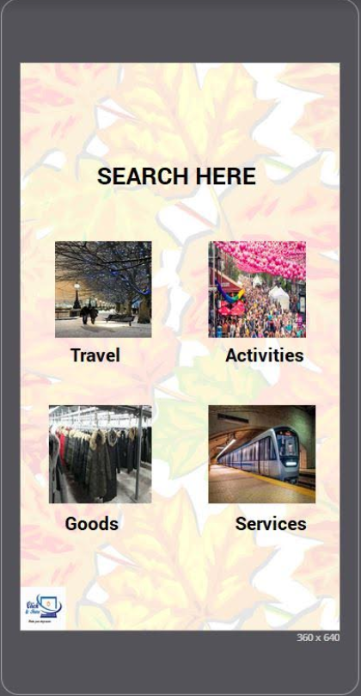

Existing User

**Login page Search page**

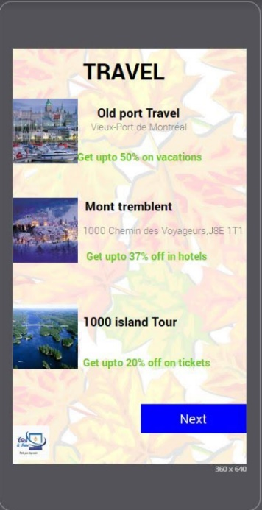

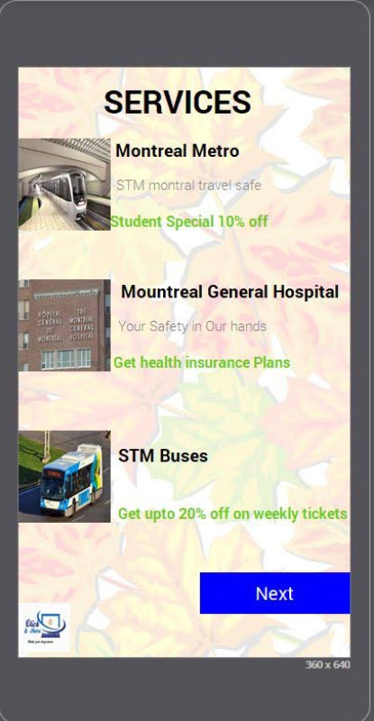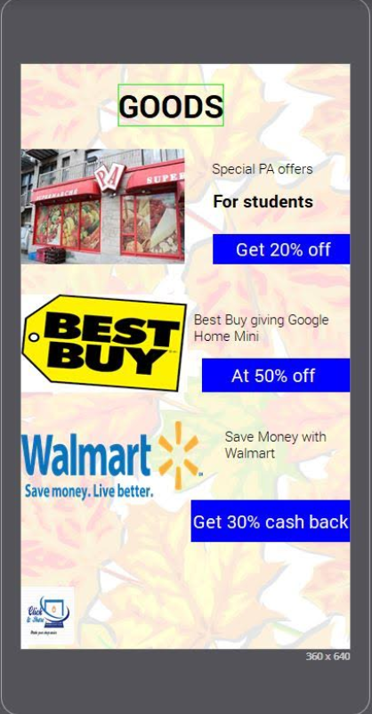

 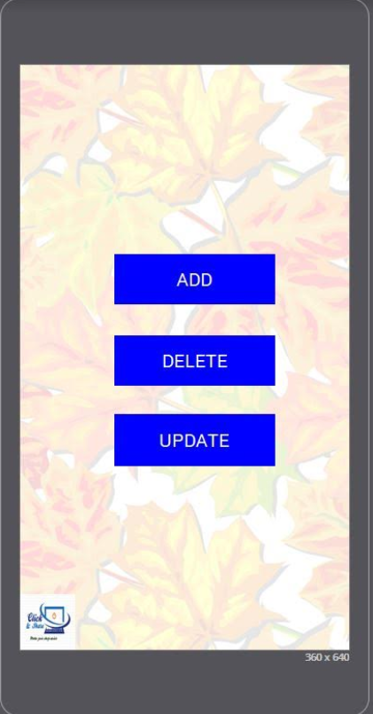

**Login page Admin home page**

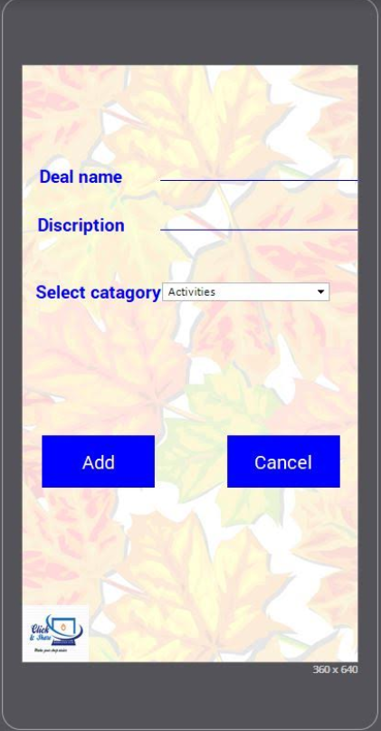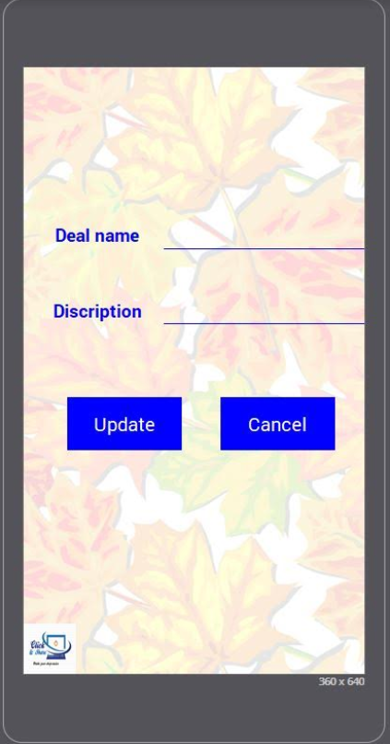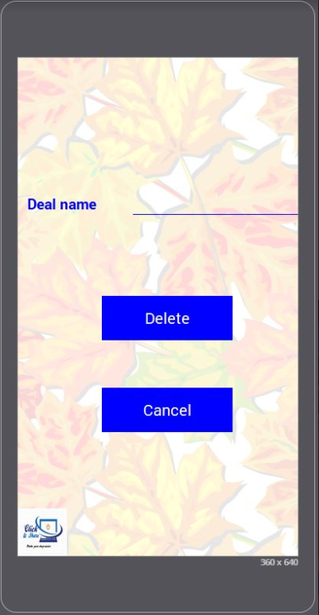

**Add deals Update Deals Delete Deals**

**Database Schema**

A schema contains schema objects, which could be tables, columns, data types, views, stored procedures, relationships, primary keys, foreign keys, etc. A database schema can be represented in a visual diagram, which shows the database objects and their relationship with each other.

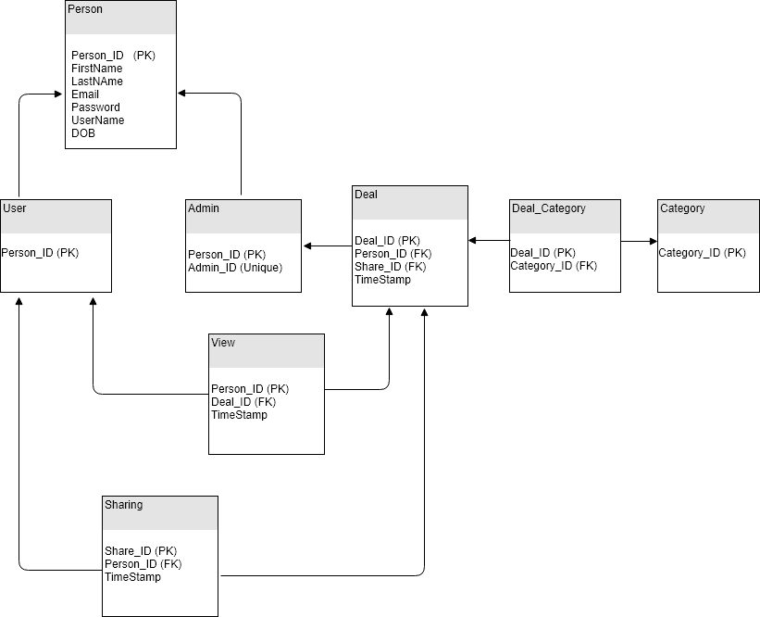

**Figure 1.4 Database Schema**